Medical Services Plan - Teleplan
Medical Services Plan (MSP) provides an application solely for practitioners called Teleplan4 (v4), aka Teleplan Web, for telecommunication to transmit and receive medical claims data electronically.

Teleplan Introduction
MSP's Teleplan access provides a means for you to send and receive your claims-related files securely across the internet. MSP's Teleplan application allows practitioners to send their claims to MSP's mainframe host computer in a machine-readable format. Teleplan does not replace the billing software supplied by your vendor.

Teleplan Claims Submission and Processing
Teleplan is a telecommunications system which allows practitioners to securely submit claims and notes, retrieve remittance information, and check patient eligibility over an encrypted internet connection with MSP.
The system is built to industry standards for secure internet communications (like that used for online banking transactions).
Teleplan receives and processes over 9million claims monthly, valued at approximately $330 million. Approximately 98.8% of all claims are processed within 30 days, with the majority being paid within 14 days. Processing times depend on the timing of the submissions and the complexity of the claims. Payments are made at the middle and end of each month, either by electronic funds transfer or by cheque.

Teleplan Support Centre
The Teleplan Support Centre handles questions about Teleplan, the Claims processing system and Teleplan specifications including:
- Electronic billing problems
- Electronic remittance statements and refusals
- MSP-practitioner-vendor liaison
- "Zapping" claims submitted with incorrect data
- Resetting revoked passwords
- Non-vendor software submission and pickup software problems
- Sequence errors
- Request for patient demographic files
- Load over-aged remittances

Use this toll-free service to reach the Teleplan Support Centre for any reason:
Vancouver (604) 456-6950
Rest of province (toll free) 1-866-456-6950
Press 3 for Teleplan, and then press 2

Teleplan Web Access
The Teleplan website can be accessed either directly using an internet web browser or using your billing software vendor’s add-on software (called Teleplan Web Services Interface). In either case, you will need to contact your vendor to establish the method they use to access Teleplan.
The internet address for Teleplan’s Production website is https://teleplan.hnet.bc.ca
Note: the internet address for a vendor’s Teleplan Web Services Interface call to Teleplan production access is https://teleplan.hnet.bc.ca/TeleplanBroker and is coded by vendors within their software.

Teleplan ISP (Internet Service Provider) Access
You can access our servers anytime (normally 24 x 7) using your private internet service provider including all our public Web services.
Example: http://www.health.gov.bc.ca/msp/infoprac/teleplan.html

Contact Teleplan Support for access information if needed.

Teleplan Web Sign-On
Teleplan Support Centre will provide you with your own Teleplan Data Centre sign-on ID and password (not the same as your private ISP ID and password). The password expires after 42 days and you will be prompted to change either if using our browser or your vendor’s TELEPLAN WEB SERVICES INTERFACE.
Teleplan Support can be contacted to help you with the above.
Note: This ID is not the same as your private ISP ID/PW. Please refer to the Web Security document in this package...

Vendors Only: Teleplan Web Vendors Test Site
Teleplan vendors cannot directly access the Teleplan production browser internet address, (https://teleplan.hnet.bc.ca) for test purposes; they must access a special internet address, (https://tlpt2.moh.hnet.bc.ca) instead.
If the vendor chooses to use the Teleplan Web Services Interface, then the internet address to use for testing purposes is https://tlpt2.moh.hnet.bc.ca/TeleplanBroker.
This vendor’s test site is a full production clone and provides the same service as Teleplan Production. For testing the eligibility request service, contact Teleplan Support for sample cases. All vendors must contact Teleplan Support for the latest detailed information on using the Teleplan Web Services Interface and to obtain approvals as a legitimate Teleplan Vendor.

Check Eligibility:
The "Check Eligibility" function provides answers to the question on patient eligibility for MSP services. It provides the same functionality as the Claims Interactive Voice Response (IVR) system and Teleplan Batch Eligibility. This web transaction provides an instant response for eligibility checking, same as the IVR.
This service from the Browser and Application Program Interface (API) is to be used for real-time ‘Point of Service’ only. At the ‘Point of Service’, the service is called by keying the patient’s Personal Health Number (PHN) to get the eligibility answer. Once the ‘Check Eligibility’ answer is positive for a patient, the answer is honored by MSP for the date of service requested up to the end of the month of the date of service requested. Therefore, it is not necessary to request ‘Check Eligibility’ again for the same patient for the rest of the month.
Batching of patients to check eligibility is NOT ALLOWED.
NOTE: Acceptable Use Policy: The Teleplan Check Eligibility function and equivalent function in the API is intended for real-time Point-of-Service checks only for unknown or previously unseen clients that have not scheduled visits in advance. Automated calls and batching of patients to check eligibility are NOT ALLOWED. Transaction utilization is continuously monitored. Automated, repeated or high volume jobs will not be processed (i.e. refused) and the transaction will be disabled for data centers and practices that do not conform to the Acceptable Use Policy.
For multiple eligibility checks, use the Teleplan Batch Eligibility (B04) as part of the Claims Submission. This is the only approved method to determine eligibility for repeat clients and planned visits (e.g. physician or practice roster checks) and the preferred method for returning eligibility.

Sample browser screens follow, next two pages:
Sample 1: Teleplan Web sign-on screen: shows URL and sign-on page
Sample 2: Teleplan Web Home page: Shows main business functions selection page

Sample 1: Teleplan Web Sign on Screen:
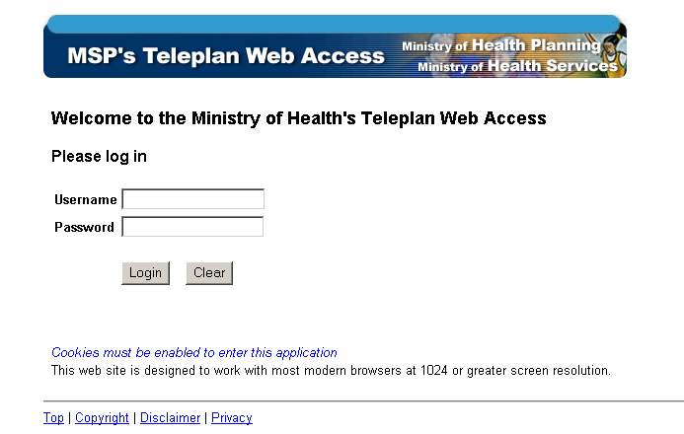

Sample 2: Teleplan Web Home Page:
